**Testing JAVA Applications and Writing Test Cases**

---------------------------------------------------------------------------------------------------------------------------

After completing this handson you will be able to **write Test cases** irrespective of any **testing framework**

For eg: consider three screens.

* A login screen
* An employee display screen, which lists all employees in the organization
* An employee modification/addition/removal screen.

The UI (User Interface) for these three screens are developed with JSP/HTML and the validations performed through JavaScript. Because it is a sample application, logic is in the Servlet and DAO (Data Access Object). DAO is a class for connecting to the database.

**Below are the sample screens:**

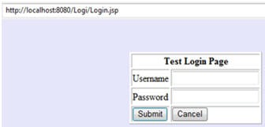

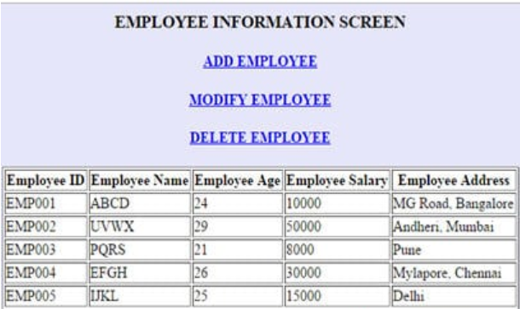

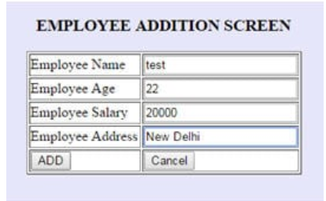

### **Manual Java Application Testing:**

During manual JAVA testing, a tester prepares the test cases from the detailed design document and tries to cover every scenario and code snippet possible.

**JAVA UNIT TESTING**

[Unit testing is a type of testing](https://www.softwaretestinghelp.com/unit-testing/) wherein a user needs to test the smallest of the code snippets for accuracy, correctness and meeting the requirements

Let us take the example of the login screen. The login screen has two text fields: username and password, and has two buttons: submit and cancel.

The test cases should cover all the loops and conditional statements. Test cases should display the expected results and the test data. Below are some of the general test cases that a user could execute manually in a login screen. The results are then noted down in the test case document.

**Below is a sample test case format for the login screen.**

| **S.No.** | **Test Case** | **Expected Result** | **Actual Result** | **Pass/Fail** |
| --- | --- | --- | --- | --- |
| 1 | User checks the appearance of labels Username, Password | The labels should be correctly spelled and displayed in Normal sized font | The label username and password are displayed correctly | PASS |
| 2 | User checks the appearance of the button Submit and Cancel | The buttons should be displayed with the correct name | The buttons Submit and Cancel are displayed correctly | PASS |
| 3 | User checks the background color of the screen | The login form should be within a white table and the screen should be of background grey | The screen appearance does not match the requirements. | FAIL |
| 4 | The user leaves username textbox as Blank | Error message “Username cannot be empty” should be displayed | Error message “Username cannot be empty” is displayed | PASS |
| 5 | The user enters some value in the username textbox and leave the password textbox as Blank | Error message “Password cannot be empty” should be displayed | Error message “Password cannot be empty” is displayed | PASS |
| 6 | User enters username as “abcd” and password as “xxxx” | Error message “Invalid username password combination” should be displayed | Error message “Invalid username password combination” is displayed | PASS |
| 7 | User enters a username of more than 10 characters | Error message  “Username should not be more than 10 characters” should be displayed | Error message is not displayed | FAIL |
| 8 | User enters username as “testuser” and password as “password” and clicks the Submit button | The user should be able to see the “Employee details screen” | Employee details screen is displayed | PASS |
| 9 | Check numbers and special characters are not allowed in username | Numbers and special characters are not allowed in username. | Numbers and special characters are not allowed in username. | PASS |
| 10 | Check password is of correct length(more than 8 characters but less than 20 characters) | Password is of correct length | Password is of correct length | PASS |
| 11 | Check submit and cancel button work as per requirement | Submit and cancel button work as per requirement | Submit and cancel button work as per requirement | PASS |
| 12 | Check username and password accept both upper case and lower case characters | username and password accept both upper case and lower case characters | username and password accept both upper case and lower case characters | PASS |
| 13 | Check if the username and password entered are valid credentials. | Username and password entered are valid credentials. | Username and password entered are valid credentials. | PASS |

After going through the test cases, you may realize that you are mostly dealing with the testing of fields, buttons, functionality, and validations of a particular screen. This is accurate, as Unit Testing very keenly deals with the testing of every small code snippet and component. The same type of testing should be performed for all the screens.

Tests for Employee Addition

|  |  |  |  |  |
| --- | --- | --- | --- | --- |
| S.No. | **Test Case** | **Expected Result** | **Actual Result** | **Pass/Fail** |
| 1 | Check Employee Name consists of only lower case and upper case alphabets and is of required length. | Employee Name consists of only lower case and upper case alphabets and is of required length. | Employee Name consists of only lower case and upper case alphabets and is of required length. | PASS |
| 2 | Check Employee age consists only of numbers | Employee age consists only of numbers | Employee age consists only of numbers | PASS |
| 3 | Check Employee salary consists only of numbers | Employee salary consists only of numbers | Employee salary consists only of numbers | PASS |
| 4 | Check Employee address consists of only lower case and upper case alphabets and is of required length | Employee address consists of only lower case and upper case alphabets and is of required length | Employee address consists of only lower case and upper case alphabets and is of required length | PASS |
| 5 | Check add and cancel button work as per requirement | Add and cancel button work as per requirement | Add and cancel button work as per requirement | PASS |